Agarose gel showing the amplified polymorphic DNA band with primer URP 1F in isolates of Bipolaris spp. Lanes:

M, 1 kb molecular marker (Fermentas);

1, B. tetramera; 2, B. specifera; 3, B. maydis; 4, B. oryzae; 5, B. sorokiniana BS8; 6, B. sorokiniana BS28; 7, B. sorokiniana BS34; 8, B. sorokiniana BS75.

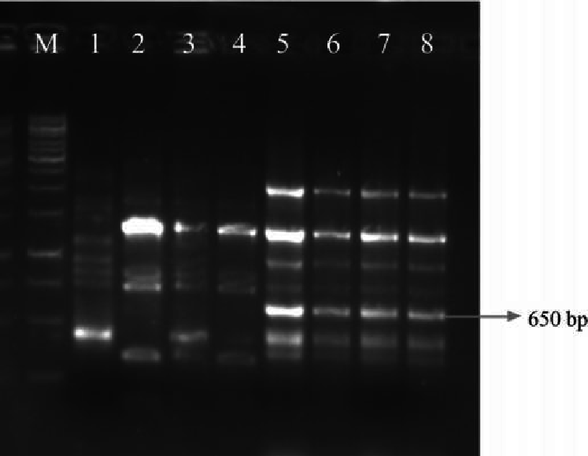

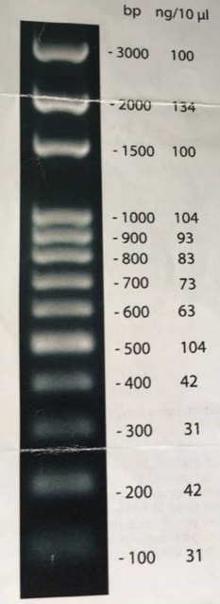
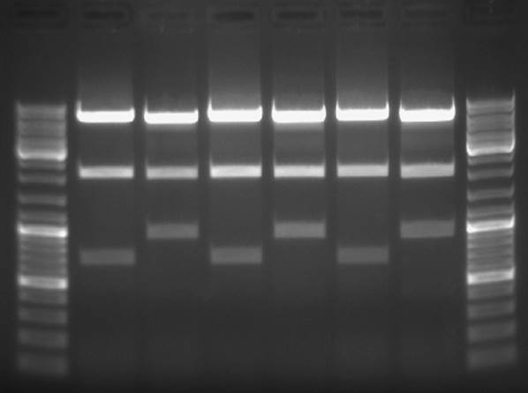
100bp
3000bp pb
P
P
E
E
D
C
B
A
Amostras

